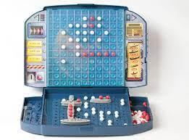 Final Summative – Battleship Tournament 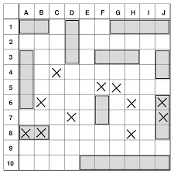

Name: Aiden Wang

| Date | Tasks/Progress |
| --- | --- |
| Jan. 11, 2022 | Completed Project Charter for initiation.  Contributed to algorithm writing. (at least 50% done) |
|  |  |
|  |  |
|  |  |
|  |  |
|  |  |
|  |  |